SIT314/SIT729 – Week 3 Group Activity
The Impact of IoT on our lives

Overview

The aim of this activity is to plan the communications and connectivity for a distinct application.

Resource mining is a high-cost high-reward industry, which rapidly adopts new technologies to manage those costs. IoT has had a substantial impact on automating mining. Dassault Systems has produced the following image which summarises the use of IoT technologies in mining for their GEOVIA modelling software. For us, this provides a nice case study of the use of IoT in an environment that needs to be resilient and scalable.

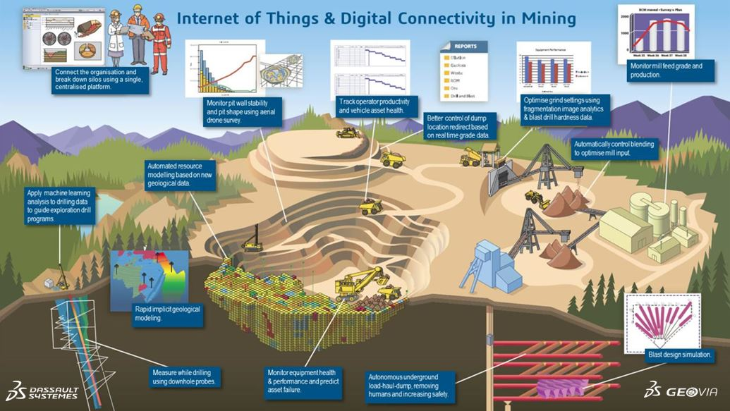

Tasks
For the application `Vehicle Asset Health` identified in the image.

- What functionality is needed for this application? What should be sensed, what processing is needed and what actuation is possible?

- Functionality: this application must be able to detect the current “health status” of a vehicle based on the following factors:
  - Vehicle parameters:
    - Engine temperature.
    - Oil pressure.
    - Fuel levels.
    - Tire pressure.
    - Brake wear.

  - Operational data:
    - Speed.
    - Runtime hours.
    - Load weight.

  - Driver behaviours:
    - Acceleration patterns.
    - Braking frequency.

- Processed:
  - Data Analysis: Real-time analysis to detect anomalies (e.g., engine overheating, abnormal vibrations).
  - Predictive Maintenance: Algorithms to predict when maintenance is needed based on sensor data trends.
  - Diagnostics: Fault code generation and prioritization (e.g., critical vs. non-critical issues).
  - Aggregation: Combining data from multiple vehicles for fleet-wide insights.
  - Alerts: Generating notifications for maintenance teams or operators when thresholds are exceeded.

- Actuated:
  - Alerts/Notifications: Sending warnings to drivers (e.g., dashboard alerts) or maintenance crews (e.g., via mobile apps or control centers).
  - Automated Controls: Shutting down a vehicle in critical failure scenarios or limiting speed if unsafe conditions are detected.
  - Maintenance Scheduling: Automatically logging maintenance requests in a central system.
  - Reporting: Generating reports for fleet managers on vehicle health status.

- What web services would you need to structure to implement this?
- Data Collection Service:
  - Purpose: Collects sensor data (e.g., engine temperature, GPS) from vehicles.
  - Implementation: RESTful API (e.g., POST /vehicles/{vehicle_id}/sensors) to receive data from IoT devices on vehicles.
  - Example: Vehicles send JSON payloads with sensor readings to a cloud endpoint.

- Data Processing Service:
  - Purpose: Processes raw sensor data for anomaly detection and predictive maintenance.
  - Implementation: A microservice that consumes sensor data, runs analytics (e.g., machine learning models), and stores results in a database.
  - Example: POST /analytics/process to trigger analysis and return diagnostic results.

- Notification Service:
  - Purpose: Sends alerts to drivers, maintenance teams, or fleet managers.
  - Implementation: REST API or WebSocket for real-time notifications (e.g., POST /notifications/alert to send emails, SMS, or app notifications).
  - Example: Alerts for critical issues like engine failure.

- Maintenance Scheduling Service:
  - Purpose: Logs and schedules maintenance tasks based on processed data.
  - Implementation: REST API (e.g., POST /maintenance/schedule) integrated with a maintenance management system.
  - Example: Creates a work order for a vehicle needing tire replacement.

- Dashboard Service:
  - Purpose: Provides a user interface for fleet managers to monitor vehicle health.
  - Implementation: GET /dashboard/vehicles to retrieve real-time and historical data for visualization.
  - Example: Displays vehicle status, alerts, and maintenance schedules.

- Authentication/Authorization Service:
  - Purpose: Secures access to services and data.
  - Implementation: OAuth 2.0-based API (e.g., POST /auth/token) to authenticate users and devices.
  - Example: Ensures only authorized personnel access sensitive vehicle data.

- Assumptions: Services are cloud-based, scalable, and use standard protocols like HTTPS for security.

- What hierarchical MQTT topics would you use?

- For Vehicle Asset Health, topics should reflect the mining site, vehicle, and data type.

- Possible topic structure:
“mining/{site_id}/{vehicle_id}/{data_type}/{sensor_type}”

- Where:
  - site_id: Unique identifier for the mining site (e.g., siteA).
  - vehicle_id: Unique vehicle identifier (e.g., truck001).
  - data_type: Category of data (e.g., sensors, alerts, commands).
  - sensor_type: Specific sensor or action (e.g., engine_temp, tire_pressure, maintenance).

- Example Topics:
  - Sensor Data:
    - mining/siteA/truck001/sensors/engine_temp: Publishes engine temperature readings.
    - mining/siteA/truck001/sensors/tire_pressure: Publishes tire pressure data.
  - Alerts:
    - mining/siteA/truck001/alerts/critical: Publishes critical alerts (e.g., engine failure).
    - mining/siteA/truck001/alerts/warning: Publishes non-critical warnings (e.g., low fuel).
  - Commands:
    - mining/siteA/truck001/commands/shutdown: Sends a command to shut down the vehicle.
    - mining/siteA/truck001/commands/schedule_maintenance: Triggers a maintenance request.
- Wildcards for Filtering:
  - Single-level (+): Subscribe to mining/siteA/+/sensors/engine_temp to receive engine temperature data from all vehicles at siteA.

  - Multi-level (#): Subscribe to mining/siteA/truck001/# to receive all messages for truck001 (sensors, alerts, commands).

  - Fleet-wide Monitoring: Subscribe to mining/+/+/sensors/# to monitor sensor data across all sites and vehicles.

Based on this, continue with the following.

- Create a high-level block diagram of the scenario, include the all the people, places and things that are involved in the scenario.

Decide what wireless communications technology to use.

- Create a simple data flow diagram showing all the needed communication in this system.

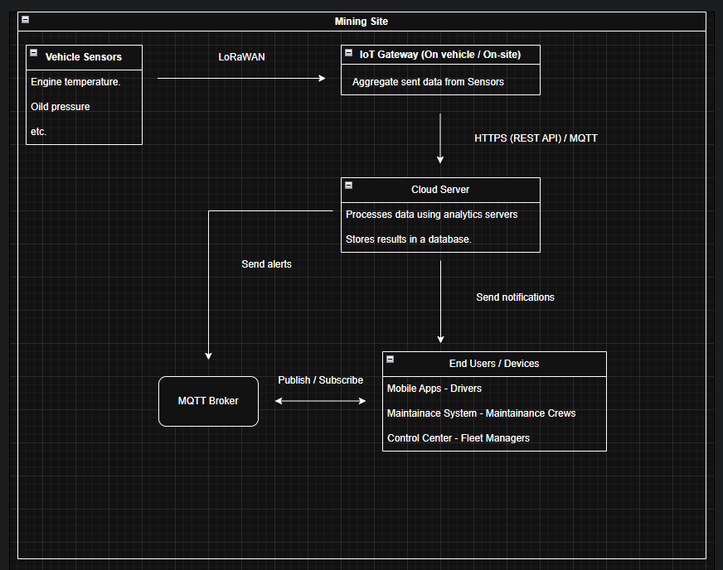

Diagram 1 – Flow diagram for both question 4 & 5.

Design two approaches to this application:

- Plan a web service-based approach to implementing the application-level communications for this application. What services would you need?

• Services Needed
- Sensor Data Ingestion:
  - Endpoint: POST /vehicles/{vehicle_id}/sensors
  - Function: Receives JSON payloads with sensor data (e.g., { "engine_temp": 85, "tire_pressure": 30 }).
  - Security: Authenticated via OAuth 2.0 device tokens.
- Analytics Service:
  - Endpoint: POST /analytics/process/{vehicle_id}
  - Function: Runs predictive maintenance algorithms and generates diagnostics.
  - Output: Stores results in a database and triggers alerts if needed.
- Alert Service:
  - Endpoint: POST /notifications/alert
  - Function: Sends notifications via email, SMS, or push notifications to users.
  - Example: { "vehicle_id": "truck001", "message": "Engine overheating", "priority": "critical" }.
- Maintenance Service:
  - Endpoint: POST /maintenance/schedule
  - Function: Creates work orders in a maintenance system.
  - Integration: Connects to existing enterprise maintenance software.
- Dashboard Service:
  - Endpoint: GET /dashboard/vehicles/{site_id}
  - Function: Returns vehicle health data for visualization (e.g., JSON with status, alerts, and maintenance history).
- Command Service:
  - Endpoint: POST /vehicles/{vehicle_id}/commands
  - Function: Sends commands to vehicles (e.g., shutdown, speed limit).
  - Security: Restricted to authorized users (e.g., fleet managers).
• Architecture:
- Microservices: Each service is independently deployable, using a cloud platform like AWS or Azure.
- Database: A NoSQL database (e.g., MongoDB) for storing sensor data and analytics results.
- API Gateway: Manages routing, authentication, and rate limiting for all services.
- Scalability: Services scale horizontally to handle large fleets.
- Security: HTTPS, OAuth 2.0, and role-based access control (RBAC) for users and devices.

- Plan a hierarchical MQTT application-level communications protocol. Think about the identity of users and devices in the system and plan single-level or multi-level wildcards for message filtering.

• Identity Management:
- Devices:
  - Each vehicle has a unique ID (e.g., truck001) embedded in MQTT topics.
  - IoT Gateways have IDs (e.g., gatewayA) for aggregating data from multiple vehicles.
  - Devices authenticate with the MQTT broker using client certificates or username/password pairs.
- Users:
  - Drivers: Subscribe to vehicle-specific alerts (e.g., mining/siteA/truck001/alerts/#).
  - Maintenance Crews: Subscribe to site-wide alerts (e.g., mining/siteA/+/alerts/#).
  - Fleet Managers: Subscribe to fleet-wide data (e.g., mining/+/+/sensors/#).
  - User authentication is handled via a separate authentication service (e.g., OAuth 2.0 tokens mapped to MQTT subscriptions).
• Topic Hierarchy:

“mining/{site_id}/{vehicle_id}/{data_type}/{sensor_type_or_action}”
- Examples:
  - Sensor data: mining/siteA/truck001/sensors/engine_temp
  - Alerts: mining/siteA/truck001/alerts/critical
  - Commands: mining/siteA/truck001/commands/shutdown
- Gateway Topics:
  - mining/siteA/gatewayA/sensors/aggregated: Publishes aggregated data from all vehicles at siteA.
- Control Center Topics:
  - mining/siteA/control_center/commands: Publishes commands to all vehicles at siteA.
• Wildcard Usage:
- Single-level (+):
  - Maintenance crews subscribe to mining/siteA/+/alerts/critical to receive critical alerts from all vehicles at siteA.
  - Drivers subscribe to mining/siteA/truck001/+/critical to receive critical alerts for their vehicle.
- Multi-level (#):
  - Fleet managers subscribe to mining/+/+/sensors/# to monitor all sensor data across all sites.
  - Control centers subscribe to mining/siteA/# for all messages from siteA.
- Security Considerations:
  - Use Access Control Lists (ACLs) in the MQTT broker to restrict subscriptions (e.g., drivers can only subscribe to their own vehicle’s topics).
  - Encrypt payloads with TLS to protect sensitive data.
• Message Flow:
- Publish: Vehicles publish sensor data to mining/siteA/truck001/sensors/*.
- Subscribe: Maintenance crews subscribe to mining/siteA/+/alerts/# for real-time alerts.
- Command: Control centers publish to mining/siteA/truck001/commands/* to send instructions.
- Aggregation: Gateways publish aggregated data to mining/siteA/gatewayA/sensors/aggregated.

